

**Instituto Politécnico Nacional**

**Escuela Superior de Cómputo**

**Ingeniería en Sistemas Computacionales**

Análisis Fundamental de Circuitos

Práctica 5: Análisis de mallas

Profesor: Felipe De Jesús Figueroa Del Prado

Integrantes:

Luis Enrique Rojas Alvarado

Grupo: 1CM6

Index

Objective 1

**Material** **1**

**Equipment** **1**

Theoric introduction 1

**Experimental progress** **2**

**Calculations** **3**

**Circuit simulations** **4**

**Comparative of calculated, measured and simulated values** **5**

**General table** **5**

**Power table** **6**

**Measured values graph** **6**

**Power graph in each resistor** **7**

**Questionary** **7**

**Conclusions** **8**

**Bibliography** **8**

# Objective

The student will apply and verify the mesh analysis technique by measuring and calculating currents and voltages in electrical circuits composed of a series of meshes as well as the measurement of voltages and currents in a mesh circuit. Also identify how it is physically applied to a circuit based on theory.

# Material

* Breadboard
* 2 resistors (680 Ω)
* 1 resistor (560 Ω)
* 2 resistors (330 Ω)
* 1 resistor (270 Ω)
* 1 resistor (100 Ω)
* 2 resistors (1000 Ω)
* Points banana-caiman
* Points banana-banana

# Equipment

* Digital multimeter
* Variable voltage source

# Theoric introduction

Complex circuit analysis methods

When it comes to complicated circuits, such as circuits with many loops and many nodes, you can use some tricks to simplify the analysis. The following circuit analysis techniques are useful when you want to find the voltage or current for a specific device. They are also useful when you have many devices connected in parallel or in series, the devices that form loops, or a number of devices connected to a particular node.

Current mesh analysis: The mesh is a loop without devices closed by the loop, where the mesh boundaries are those devices that form the loop. Current mesh analysis allows you to find unknown mesh currents in a circuit using the Kirchhoff voltage law (LTK). Mesh equations are KVL equations with unknown mesh currents as variables. After finding mesh currents, I-v relationships are used to find the device voltajes.

Pag. 1

The method of mesh analysis consists in assigning to each grid of the circuit a current with its direction that is generally in the clockwise direction, for each grid a separate current will circulate. Once the currents are assigned, the Kirchhoff Law of voltages is written for each element of the mesh in order to obtain a mesh equation where the unknowns are the currents that circulate through each element of the mesh. If two streams flow through a branch, the total current for that branch will be the algebraic sum of the two currents. In Figure 2 the currents I1 and I2 chosen for this circuit are indicated. By applying the LKV along each mesh the mesh equations are obtained.

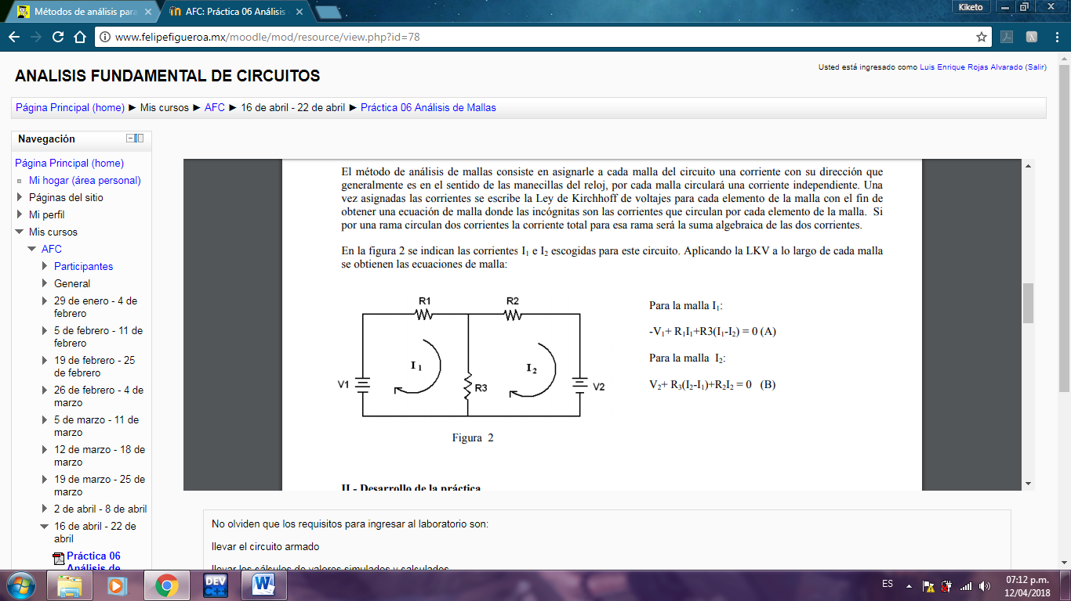

I1: -V1+ R1I1+R3 (I1-I2) = 0 (A)

I2: V2+ R3 (I2-I1) + R2I2 = 0 (B)

# Experimental progress

To start the practice, the circuit was assembled and energy was supplied through the 2 voltage sources. Once connected and energized, voltage measurements were made with the voltmeter for each resistor, then measurements of the current were made with each resistor in series.

To finish, the calculations were simply made to obtain the power value in each resistor

Pag. 2

# Calculations

To calculate the value of the current in each resistor, the mesh analysis was used, for this analysis the circuit is divided into meshes and a system of equations is obtained in which the value of the current in each resistor is obtained

In this circuit we have 4 meshes, therefore there will be 4 equations which are the following:

First equation:

$$1280i_{1}-270i_{3}-680i_{2}=12$$

Second equation:

$$-680i_{1}+2340i_{2}-560i_{4}=0$$

Third equation:

$$-270i_{1}+1280i_{3}-680i_{4}=0$$

Fourth equation:

$$-560i_{2}-680i_{3}+2240i_{4}=6$$

By solving the system of equations, currents 1, 2, 3 and 4 are obtained:

$$i_{1}=13.43mA, i_{2}=5.29mA, i_{3}=5.91mA, i_{4}=5.79mA$$

To obtain the value of the current of each resistance, the values obtained are adapted according to the value of each current:

$$R1=i_{3}=5.91mA$$

$$R2=i_{4}=5.79mA$$

$$R3=i_{3}-i_{4}=0.12mA$$

$$R4=i_{1}-i_{3}=7.52mA$$

$$R5=i_{2}-i_{4}=0.5mA$$

$$R6=i_{1}-i_{2}=8.14mA$$

$$R7=i_{2}=5.29mA$$

$$R8=i_{1}=13.43mA$$

$$R9=i_{2}=5.29mA$$

To obtain the value of the voltage in each resistance only the value of the current is multiplied by the value of the resistance:

Pag. 3

$$R1=5.91mA*330=1.95V$$

$$R2=5.79mA*1000=5.79V$$

$$R3=0.12mA*680=81.6mV$$

$$R4=7.52mA*270=2.03V$$

$$R5=0.5mA*560=0.28V$$

$$R6=8.14mA*680=5.53V$$

$$R7=5.29mA*100=0.52V$$

$$R8=13.43mA*330=4.43V$$

$$R9=5.29mA*1000=5.29V$$

# Circuit simulations

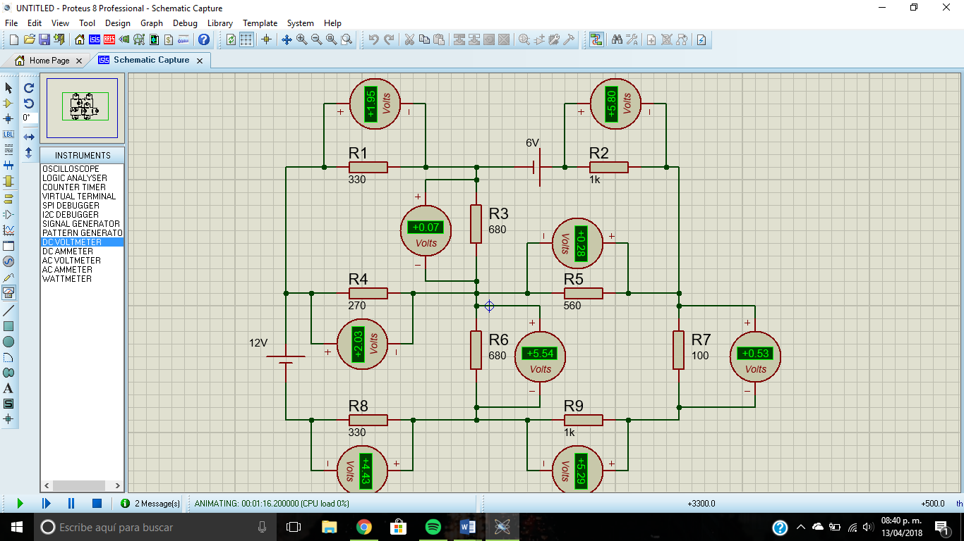

Pag. 4

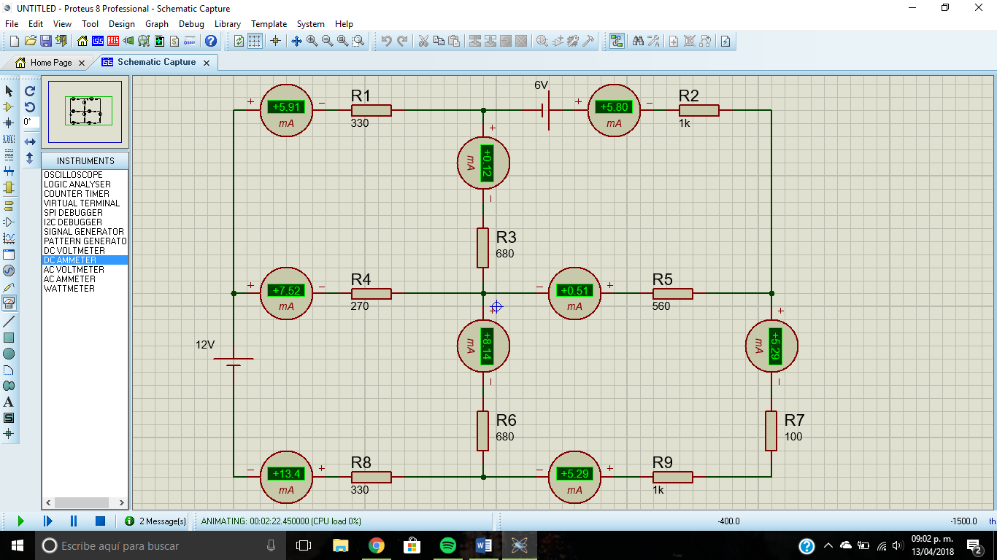

# Comparative of calculated, measured and simulated values

## General table

|  |  |  |  |  |  |  |
| --- | --- | --- | --- | --- | --- | --- |
| Element | Calculated values | | Measured values | | Simulated values | |
| Voltage | Current | Voltage | Current | Voltage | Current |
| R1 | 1.95 V | 5.91 mA | 7 V | 0.7 mA | 1.95 V | 5.91 mA |
| R2 | 5.8 V | 5.8 mA | 6.5 V | 6.6 mA | 5.8 V | 5.8 mA |
| R3 | 79.2 mV | 117 µA | 3.9 V | 4.1 mA | 74.2 mV | 117 µA |
| R4 | 2.03 V | 7.52 mA | 3.09 V | 11 mA | 2.03 V | 7.5 mA |
| R5 | 283 mV | 505 µA | 0.5 V | 4.1 mA | 283 mV | 505 µA |
| R6 | 5.54 V | 8.14 mA | 4.8 V | 11.4 mA | 5.54 V | 8.14 mA |
| R7 | 529 mV | 5.29 mA | 5 V | 4.8 mA | 529 mV | 5.29 mA |
| R8 | 4.43 V | 13.4 mA | 4 V | 12.3 mA | 4.43 V | 13.4 mA |
| R9 | 5.29 V | 5.29 mA | 5.1 V | 4.8 mA | 5.29 V | 5.29 mA |

Pag. 5

## Power table

|  |  |  |  |
| --- | --- | --- | --- |
| Element | Power values | | |
| Calculated | Measured | Simulated |
| R1 | 0.011 w | 0.0049w | 0.0115 w |
| R2 | 0.033 w | 0.042 w | 0.033 w |
| R3 | 9.26 µw | 0.015w | 8.68 µw |
| R4 | 0.015 w | 0.033 w | 0.0152 w |
| R5 | 143 µ w | 0.00205 w | 0.142 w |
| R6 | 0.045 w | 0.054 w | 0.045 w |
| R7 | 0.002w | 0.024 w | 0.00279 w |
| R8 | 0.059w | 0.0492 w | 0.059 w |
| R9 | 0.027w | 0.024 w | 0.027 w |

## Measured values graph

Pag. 6

## Power graph in each resistor

# Questionary

1. Define that it is a branch, a loop and a closed path in an electrical circuit
   1. Branch: Portion of the circuit between two consecutive nodes.
   2. Loop: Closed trajectories of a circuit.
   3. Closed trajectory: involves a set of sources, switches, resistors, semiconductors, inductors, capacitors and cables, among other components. Thanks to the closed circuit, the flow of electric current circulates between the components.
2. The calculated values of voltage and current in each resistor coincide with those measured. Why?
   1. No, since the values of the resistances are not exact as the manufacturer manufactures them, you will always see a small difference in the values but this does not indicate that they do not work the same since the difference is minimal and its change is not very noticeable.

Pag. 7

1. The calculated values of voltage and current in each resistor coincide with the simulated ones. Why?
   1. Yes, since having exact values there is no difference or loss compared to the measured
2. What are the advantages of applying the mesh analysis method?
   1. The advantage of using this technique is that it creates a system of equations to solve the circuit, minimizing in some cases the process to find a voltage or current in a circuit.

# Conclusions

In this practice it was very useful to learn about the mesh calculation, since through this we can make the physical circuit in a quick and understandable way, besides that we learn how to efficiently calculate the voltage and current that circulate through each connected element

# Bibliography:

https://analisisdecircuitos1.wordpress.com/parte-1-circuitos-resistivos-cap-21-a-30-en-construccion/capitulo-21-analisis-de-mallas/

Pag. 8